

**1.** **Homework: Computer Systems and Software – Trello**

Problems for homework for the "Software Technologies" course @ Software University.

Submit this document as your homework.

# 2. Travel Bucket List

1. Create a **new board named "Travel Bucket List"**. Do not use templates.
2. Add **a list for each continent** that you want to visit. /**Example:** Europe, Australia/
3. **Add three cards for each continent list. Each card** representing a **country or location** you want to visit. /**Example:** List Europe – cards – Paris, Italy, Fishing village in Portugal/.
4. Use **the label feature** to categorize the destinations by type (beach, adventure, culture, hobby etc.).
5. Use **the description feature** to add any must-see attractions and or activities.
6. Add **due dates** for each destination you want to visit in the next five years.
7. Delete the example photo, take a **screenshot of your board** and add it instead.

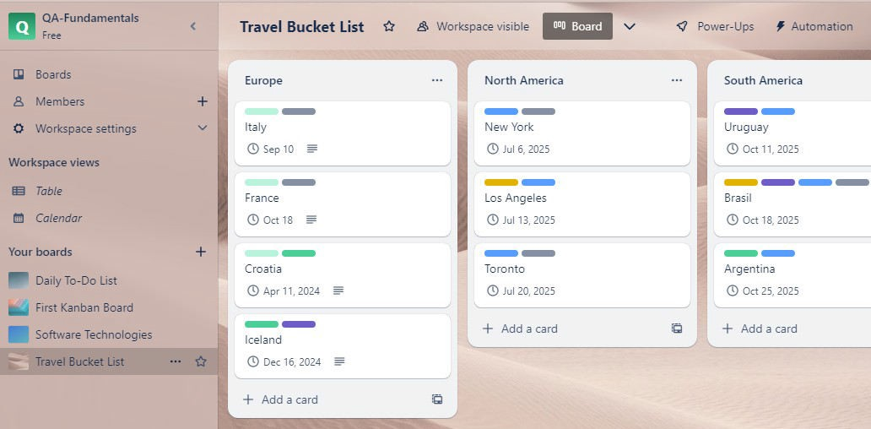

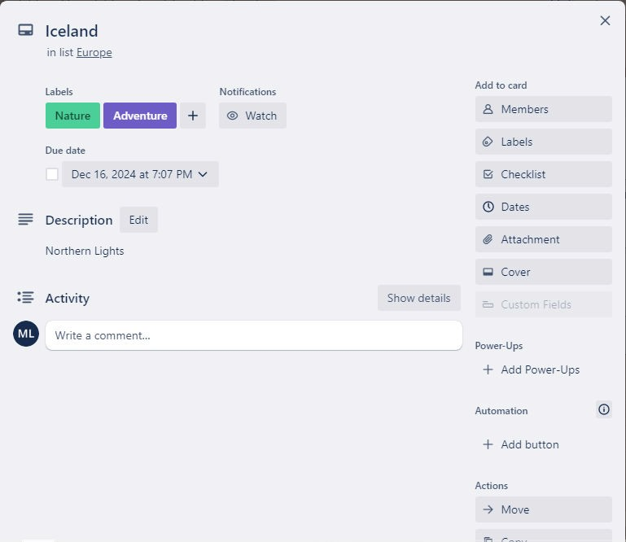

# 3. Manage your Daily Tasks

1. Create a new board named "Daily To-Do List"
2. Add a list for each category of tasks (work, personal, school, etc.)
3. Add a "Today" list for your daily tasks
4. Add cards to each list with the tasks you need to complete
5. Use the label feature to categorize the tasks by priority (high, medium, low)
6. Use the due date feature to set deadlines for each task
7. Move tasks from the category lists to the "Today" list to focus on what needs to be done
8. Use Trello's mobile app to access your to-do list on the go and check off tasks as you complete them

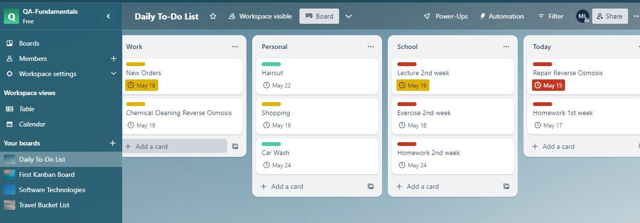

**10.** Take a screenshot of one of your cards that you already completed and add it here.

